Ilah Brows Stock Offer

2 pallets – over 50,000 units. Total RRP of counted stock £650k plus

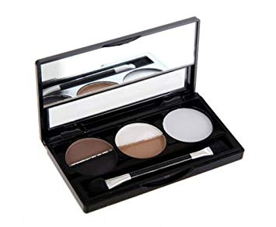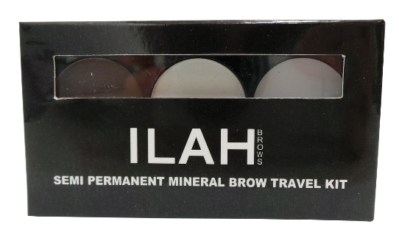

8400 units. RRP £29.99 each. Total RRP £251,916 EAN - 0610395730675

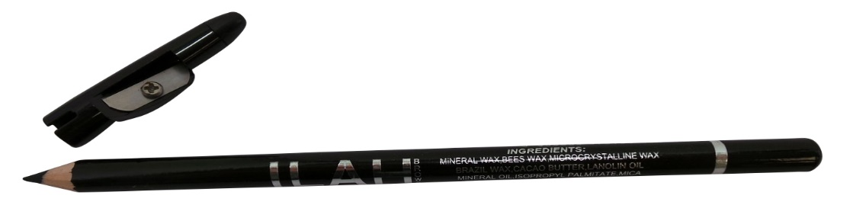

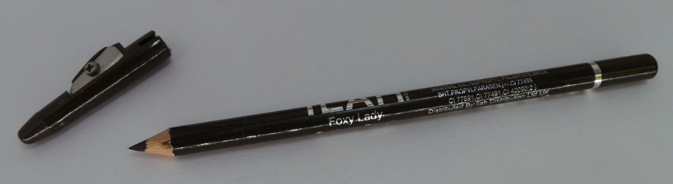

17,300 units (10,500 Brown EAN 5053839075157 - 6800 black EAN 5053539075164). RRP £10.00 each. Total RRP £173,000

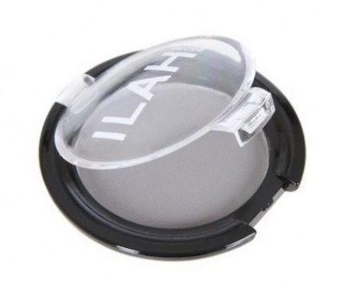1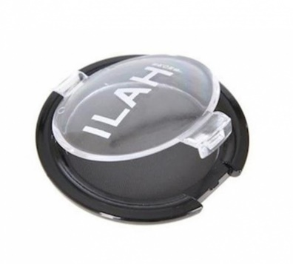2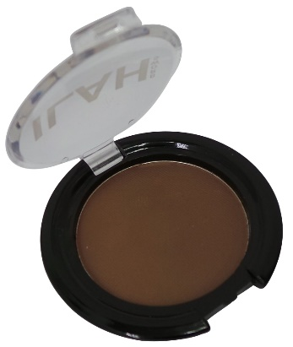3

16,780 units (680 x 1 (cannot find EAN) 6200 x 2 (EAN 0610395730613) , 9900 x 3 (EAN 0610395730620)) RRP £10.00 each. Total RRP £167,800

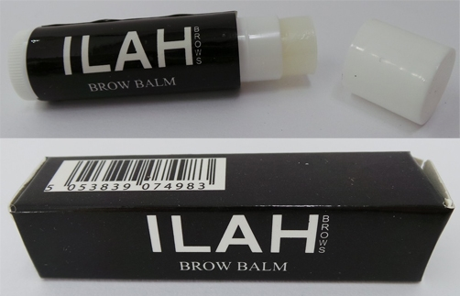

6500 units. RRP £10.00. Total RRP £65,000 – EAN 505839074983

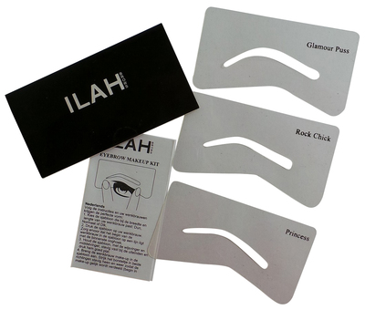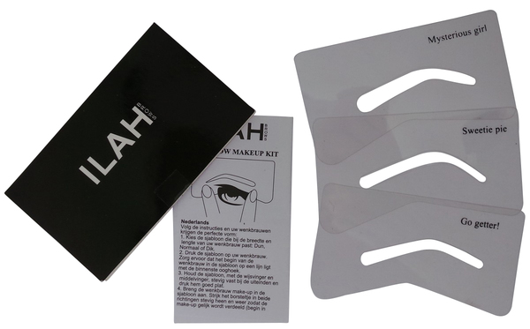

Uncounted stencils – a few thousand there – included free of charge